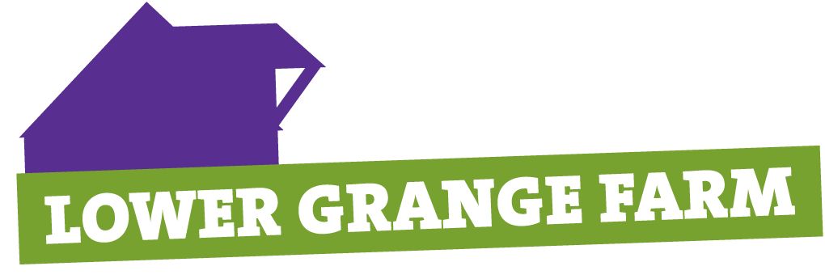






NEW FOR 2025! One extended party each weekday evening! Come on down to Lower Grange Farm, Sandling, near Maidstone with your Unit, Colony or Pack and join in the Christmas party experience with loads of fun for all. Parties take place on five nights. You must book in advance and places are strictly limited so don’t delay!

Party dates: Monday 8th December, Tuesday 9th December, Wednesday 10th December, Thursday 11th December and Friday 12th December 2025.

Party time: One party per night starting at 6pm and finishing at 8pm.

Capacity: We can accommodate 100 young people at each party – you must provide a ratio of one adult to every 6 children (adults will be expected to help during the party!). Please note that only these adults can join the young people at the party. Parents who are not part of your leadership team on the evening cannot stay to watch.

What you get:

- Christmas Wonderland Walk Through Experience
- Traditional party games
- Christmas crafts to make and take home
- Music and decorated barn
- Party food which includes – hot dog, crisps, choc bar, drink (please note if you have anyone with specific dietary requirements you must notify us of the name and details at the time of booking).
- Visit from Father Christmas with a wrapped gift for each young person.

Cost: £12 per young person. Adults are £2 each and receive hot drink and mince pie.
YOUR PLACES ARE NOT GUARANTEED UNTIL FULL PAYMENT IS RECEIVED.

Bookings: Send in the form below with a cheque made payable to KENT SCOUTS to Bunty Ridgway, 28 Warwick Crescent, Rochester, ME1 3LF. We will not be able to accept bookings without payment. You can contact Bunty on 01634 826759 to check availability. If you wish to pay by BACS please use the following details – but you must ensure you advise bunty.ridgway@kentscouts.org.uk you are making the payment.
We can only accept bookings from Units, Colonies or Packs – not from individuals. Payment by BACS is preferred and you can make this payment using the following details:
Account name Kent County Scout Council Account number 00015563 Sort Code 40 52 40
BACS reference Xmas Party and your Group name
Closing Date: Party bookings will close on 21st November 2025 (or before if event is full).
 ------------------------------------------------------------------------------------------------------------------------------------------------
Return to Bunty Ridgway either by email or post to the address above

Pack/Colony Name ………………………………………………………. Contact …………………………………….

Address …………………………………………………………………………………………………………………..

Phone ………………………………………… Email ………………………………………………………………….
Party Night  6pm – 8pm | Number of Young People @ £12 | Number of adults @ £2 | Total amount due | Please list dietary requirements
MONDAY 8TH DECEMBER

TUESDAY 9TH DECEMBER

WEDNESDAY 10TH DECEMBER

THURSDAY11TH DECEMBER

FRIDAY 12TH DECEMBER

